**NAME:JEEVITHA.S-192324020**

**DATA BASE MANAGEMENT SYSTEM FOR DATA APPLICATIONS(CSA0555)**

**ASSIGNMENT 2:**

STUDENT TABLE:

CREATE:

create table stud(student_id number,student_name varchar(50),student_deptartment varchar(50),student_CGP number);

INSERT:

insert into stud values(192324029,'jai', ' ai&ds' ,8);

insert into stud values(192324030,'jeevi',' ai&ds',7);

insert into stud values(192324031,'vicky', ' ai&ds',9);

insert into stud values(192320120,'surya','biotechnology',8);

insert into stud values(192324040,'suriya','biotechnology',9);

SELECT:

select*from stud;

TABLE:

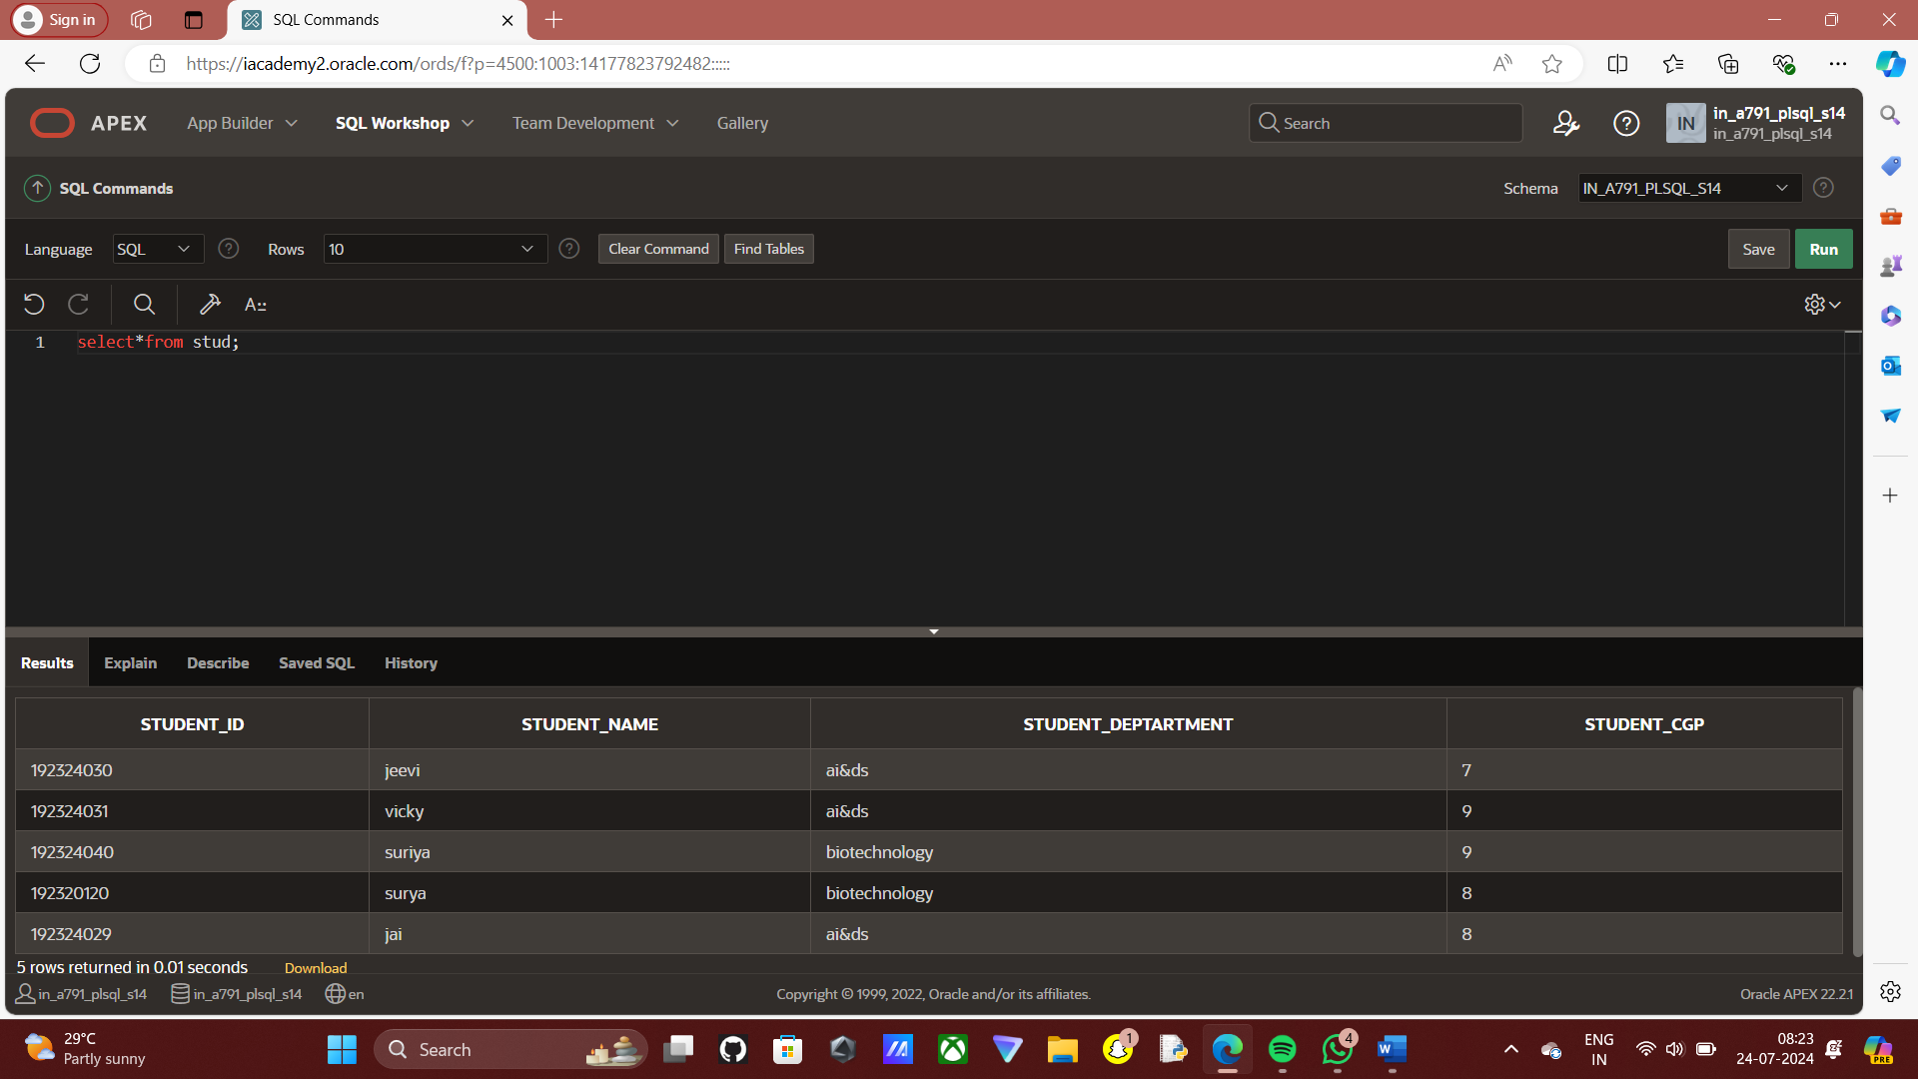

EMPLOYEE TABLE:

CREATE:

create table employee(employee_id number, employee_name varchar(50), employee_mobile number, employee_salary number);

INSERT:

insert into employee values(100,'jai',7603856507,60000);

insert into employee values(101,'jeevi',9443048805,59000);

insert into employee values(102,'surya',9443048805,55000);

insert into employee values(103,'suriya',9443048805,50000);

insert into employee values(104,'anitha',9443048805,45000);

SELECT:

select*from employee;

TABLE:

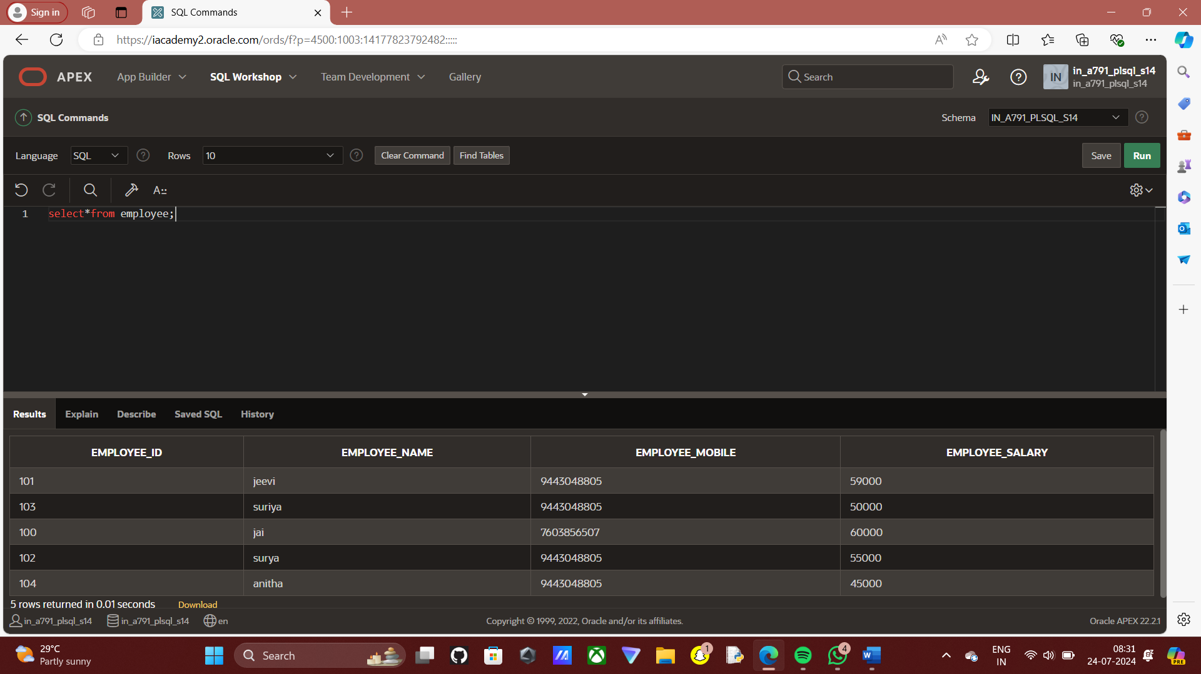

UPDATE:

update employee set employee_salary = 60000 where employee_id = 101;

SELECT:

select*from employee;

TABLE:

